Dev Diary
First, I found some research on the time that I wanted to go for which is (1700-1600) and then I investigated different buildings based on the time period. I found out what they used for the materials and investigated them more. eventually I found everything I needed and started to write my initial ideas then I started work on my mood boards, I picked out some of the textures that matched the theme of "medieval" and I wrote what I thought of the textures and how I can use them in my models, after this I went to gather some more photos of some other medieval landscapes, once I had found some photos I wrote what I thought about them and how I might use some of the concepts in my work, shortly after this I found some more photos on other medieval ideas e.g. weapons and armour, this is so I could find the right amount of damage to do to the scene or scenes, I then started to work on a barrel design that I can use across the scene to match the medieval theme, after the barrel was created + textured I exported the texture and reimported it into blender, which I then (after turning the node wrangling add-on) on I used Ctrl + shift + T to open the files, which I then selected and it was automatically placed on the mesh, after this I started to look for images based on what I wanted to go for, eventually I decided on picked a medieval market type of theme, and I searched up some images for reference, once I was happy with an image I found I made sure to keep referring back to it to make sure I was following the medieval pattern I then started work on the first “market” I started by making a block out in blender with basic cubes and flat tiles which I later deleted, then I started the main design. Before I got the plinth, I made a rough estimate on how big it would be (which I later found out how wrong I was) but I started to use that for a basic shape on how the models would be sized.

The stands

Stand 1
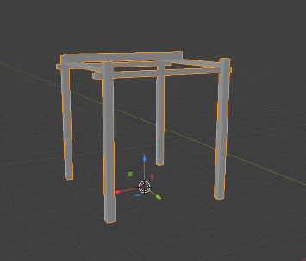
I started with a singular cube that I stretched out for a size I thought would be right for the character. Then I started to copy and paste these blocks and turn them into the shape of a stand from the medieval times.

After making this basic stand I fixed the UV for it and seamed everything so when it came to texturing it would be a lot easier then I started on a basic stand model for where I would put the boxes full of food on top of them then after I made the basic model for the stand box I seamed the edges and fixed the UV.
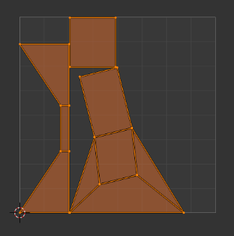
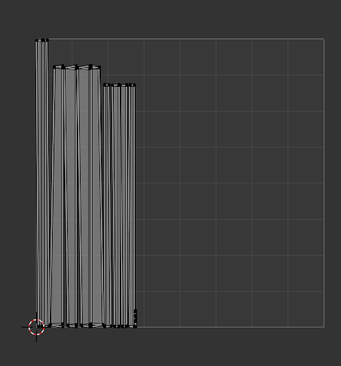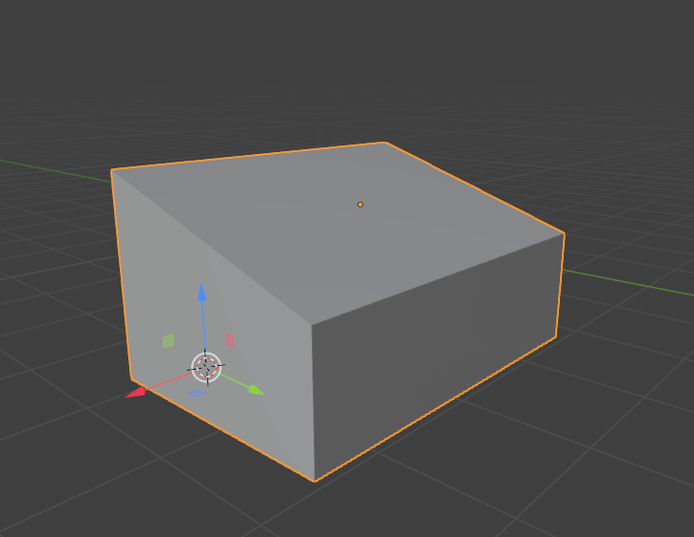

Then I started to work on the model for the box full of food for this model I overcomplicated it I started off with a plane and I grabbed one of the edges and extruded it on the Z axis then did this for all the edges at the same height.
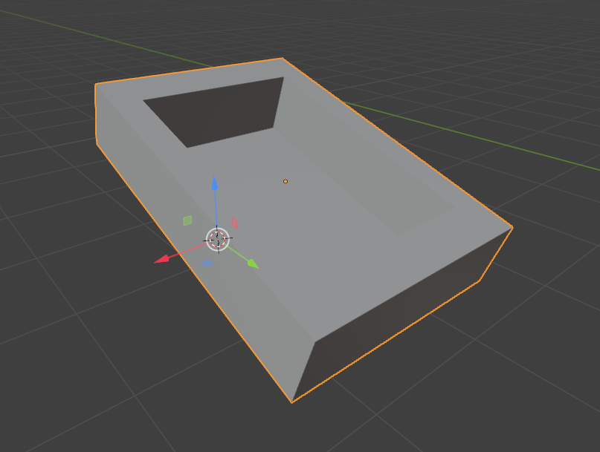

Then I looked at the UV to see if I needed to make any changes and I looked and it was fine to me, then for the texture of the fruit I decided instead of making a whole basket full of spheres and texturing them one by one I would make a plane and put the texture on that instead this would also decrease the vertices count making the project run smoother.

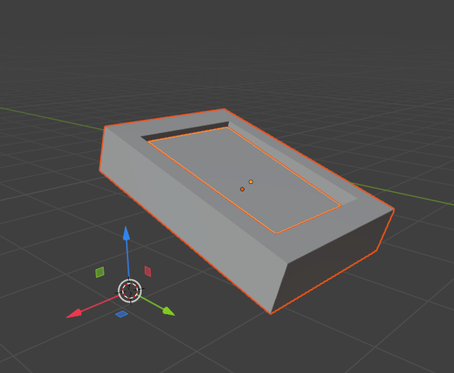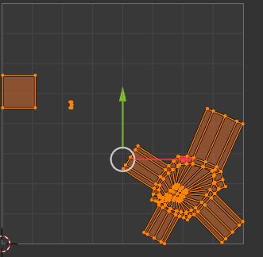
Stand 2
For stand two I used the same design as stand one for the frame and I wanted to Go for a different design on the inside of the stand, so I searched up some medieval marketplaces and wanted to go for a stand that sells “beverages” to people.

This would mean I needed a keg table and mugs which were relatively easy to make the only thing I had a problem with was the mug, I started by making a circle and selecting all vertices and pressing “f” to fill it all in, then I extruded the sides up and went back into edit mode to grab the top edge and pull it closer into the middle with the scaling tool, then I used the same trick that I did for the food box and got a circle filled it in and covered most of the top of the mug with it to save polys.
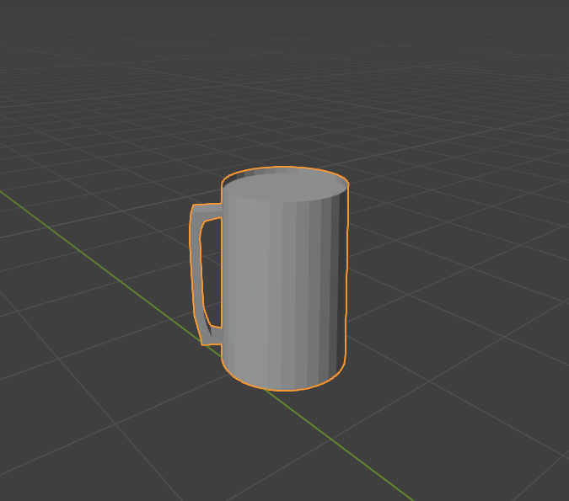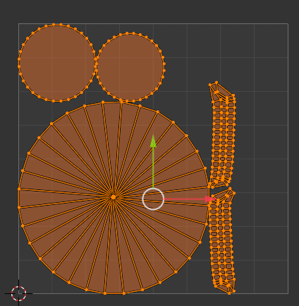

Now it was time for the table and the tabletop, these were very easy and all I did was use two cubes that were stretched and enlarged. I then checked the UV and made sure they were easy to texture when it came to texturing later.
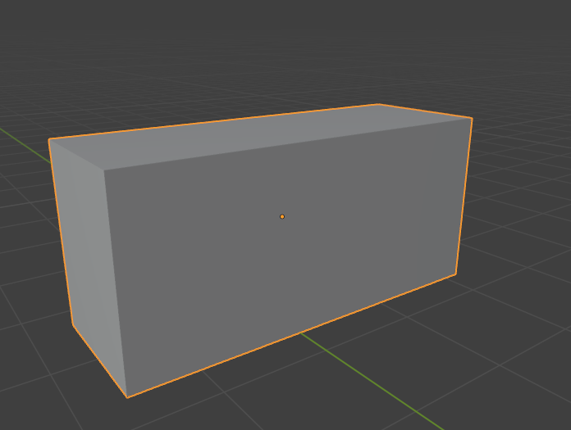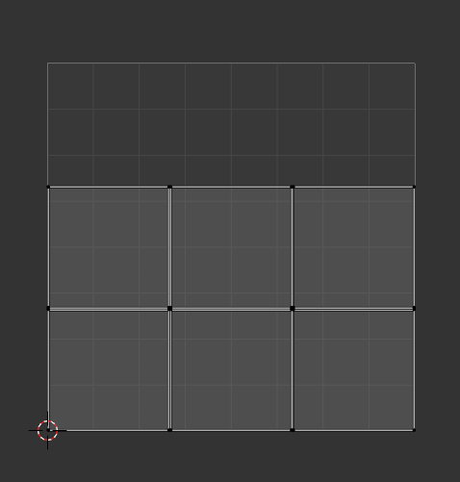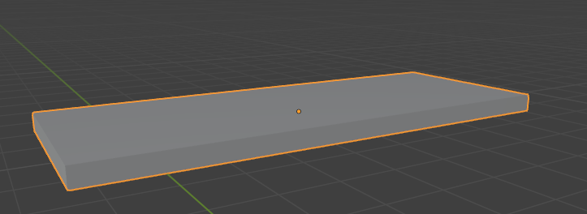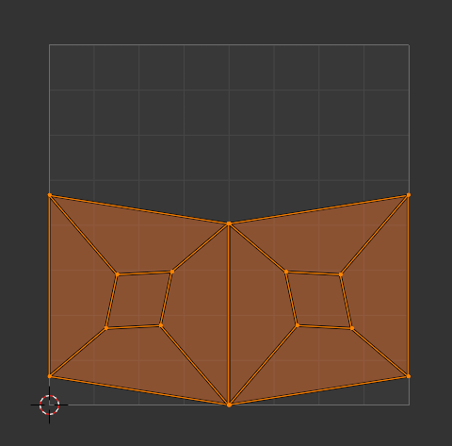
After that I started the barrel that contained the liquid. I started off with making a circle and filling it. Then I extruded it to the correct length and loop cut it about 5 times. I then pulled these edges out from the main base of the barrel, and I used the scale tool to make sure it was accurate.

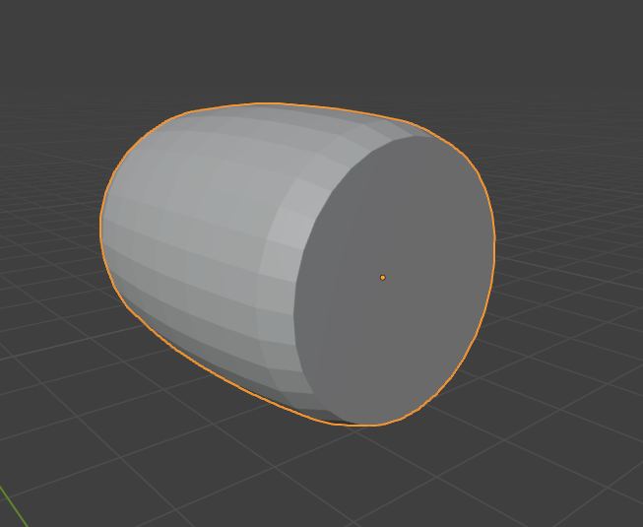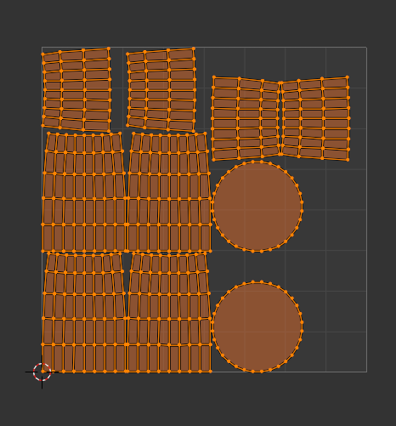

Stand 3
For stand 3 I used a different design than the rest of the stands I made a more square structure with supporting beams at the top connection one another, then I wanted to find out what to put inside of the stand so I searched up more things about medieval stands and came to the conclusion that I wanted to add pottery as that would be something that you could buy in medieval times at something like this.
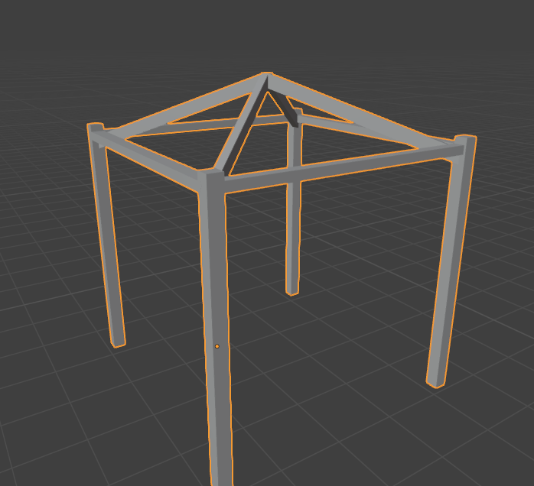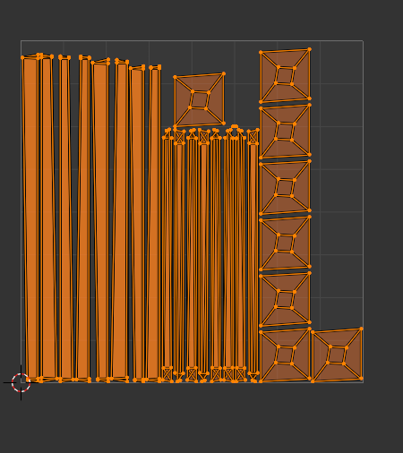

Then I started work on my assets for the stand, for the main pottery I started off with a circle and used “f” to fill it in, I then extruded the filled circle on the Z axis and loop cut the middle of the structure then by grabbing all of the sides and pulling them out of the middle of the structure I made the main shape of the pottery this was then UV’ed with the rest of the pottery and I made sure it was easy to texture.
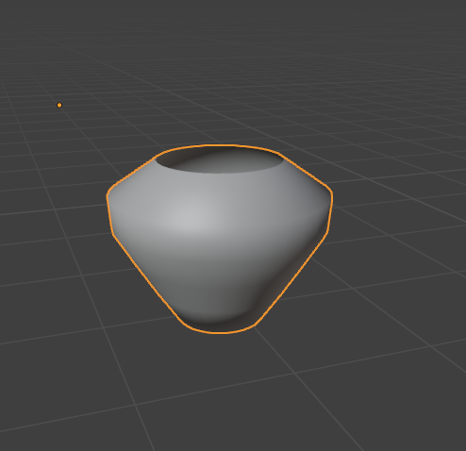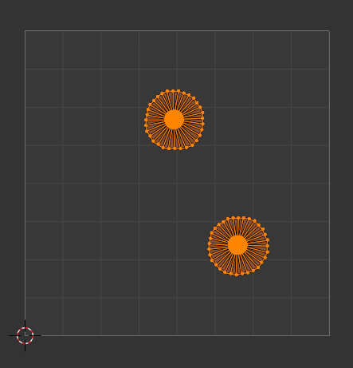 (this is without the rest of the pottery, so it looks weird, but all of them were connected to one UV)

Then I made a simple table texture which was just two extruded cubes that did not take long for me to take, However I still had to check the UV so I checked and seamed the edges so it would be really easy to texture later on.
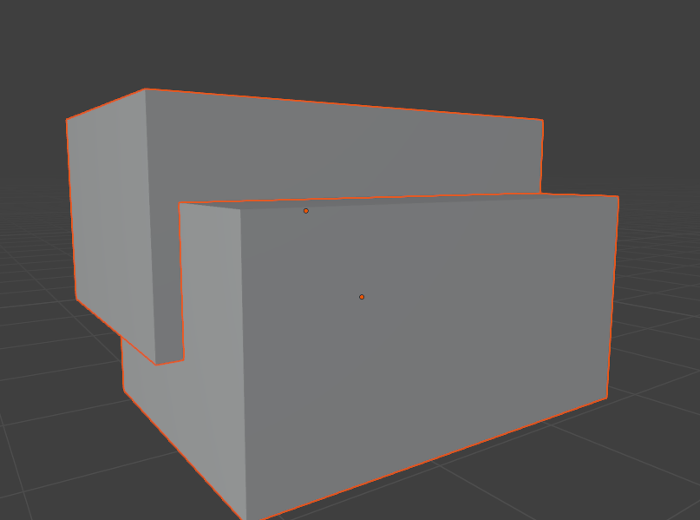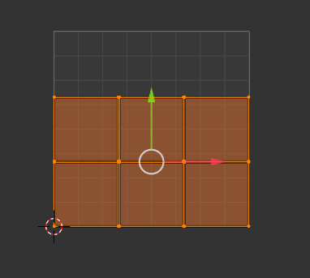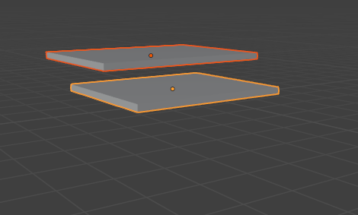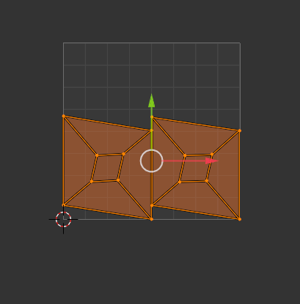

Stand 4
For stand 4 I used a very different design and instead of using my normal design I wanted to go with a more stable structure, so I added support for the main structure of the stand and made a more slanted appearance with a straight back frame then I seamed and checked the UV to make editing and texturing easy.
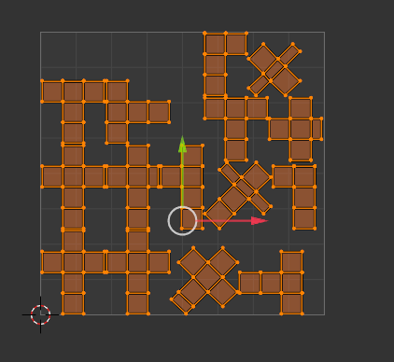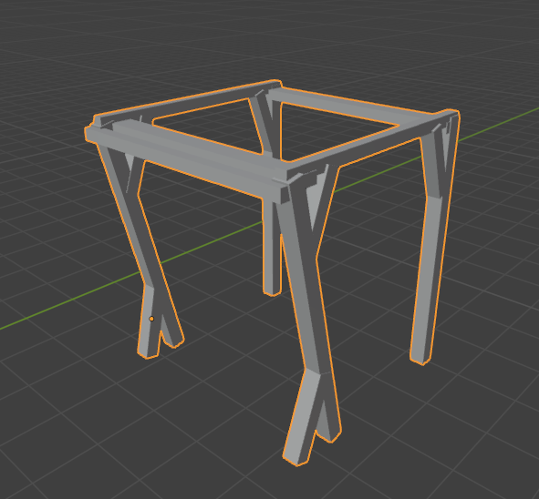

For the interior of the stand, I wanted to do something simple, so I made a box mesh which will have fruits inside of (using a plane) and a table mesh to have the boxes on top of. Both being seamed to make the UV better to deal with when I am texturing.
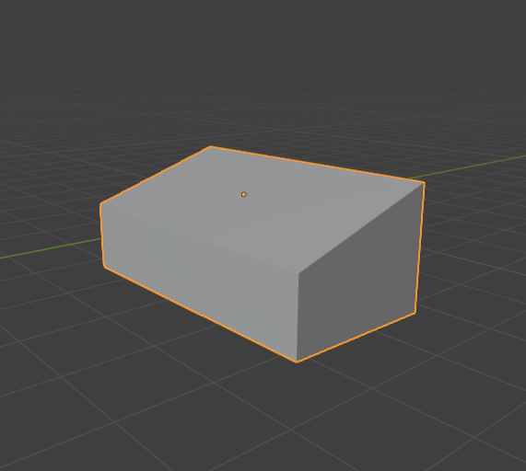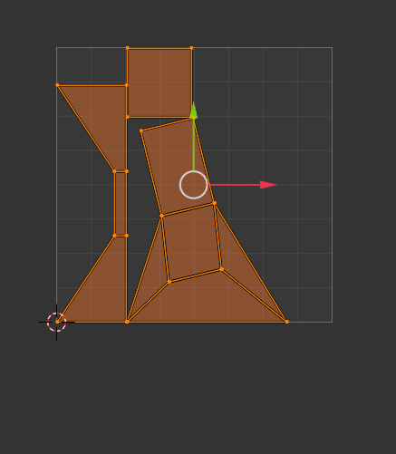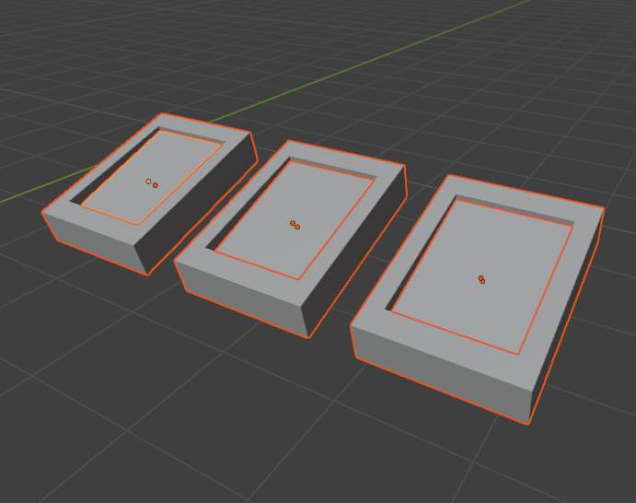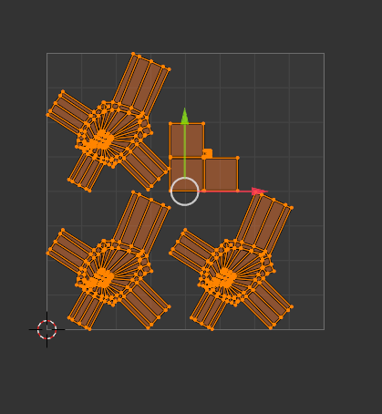

Stand 5
For stand 5 I used the same design of stand 3 as I didn’t want to make multiple different stand designs as I thought it would look less realistic, because if you see stands now most of them are the same, I wanted to have some similarities in the stands for certain ones to stand out more than the rest.
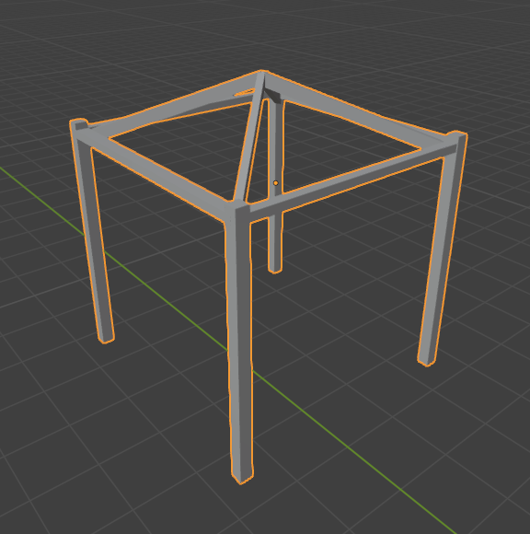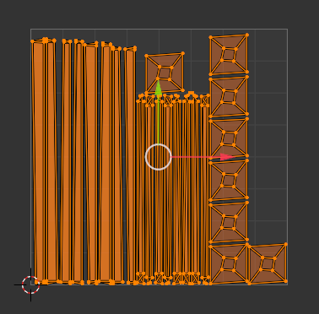

However, I changed the inside and a tiny bit of the texturing, for the inside I was going for a medieval blacksmith style which would be something common for the time for starting I made a simple anvil model by extruding a plane and bevelling the edges until it looked how I wanted it to I then tried my best to seam and make the UV as best as possible However I think I could have done better on this.
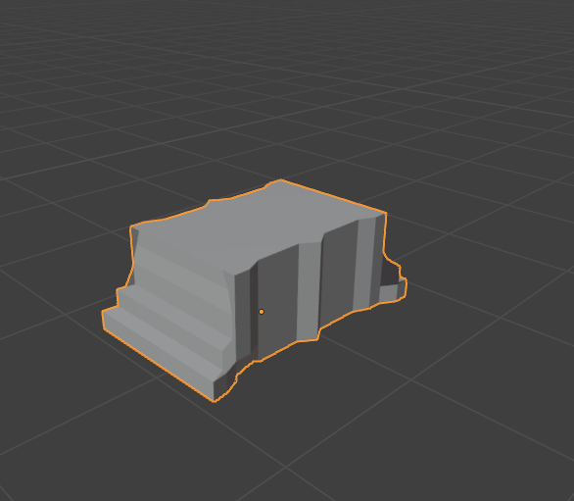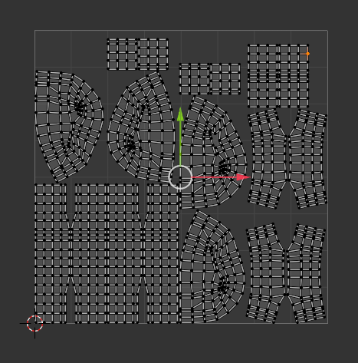

then I wanted to work on a water bucket that the blacksmith would cool the metals in, this would be the easier thing to do as all I had to do was make a circle use “f” to fill it and extrude and loop cut the side of the barrel. Then I seamed the edges until it looked how I wanted it to and finished it off with a plane that fit into the middle of it.
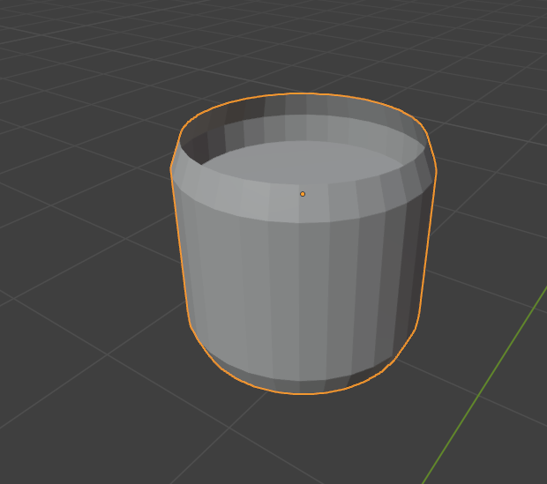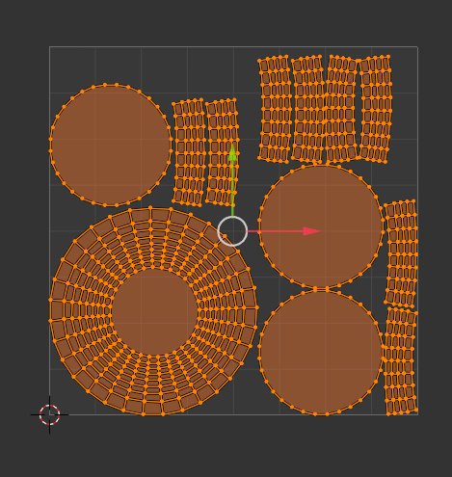
For the log holding the anvil It was very simple as all I needed to do was make a cylinder that I seamed and changed the UV to fit my texture and make it perfect.
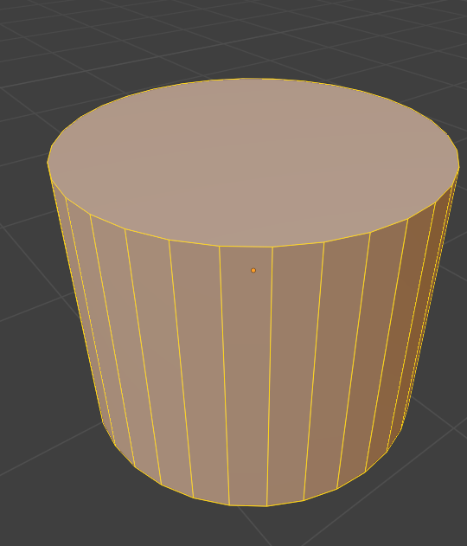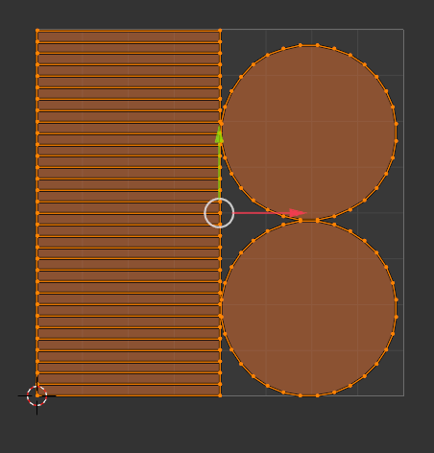
Then I started work on a basic chair model for the blacksmith to sit on this is made up from small, extruded cubes that I seamed to make the best UV possible.
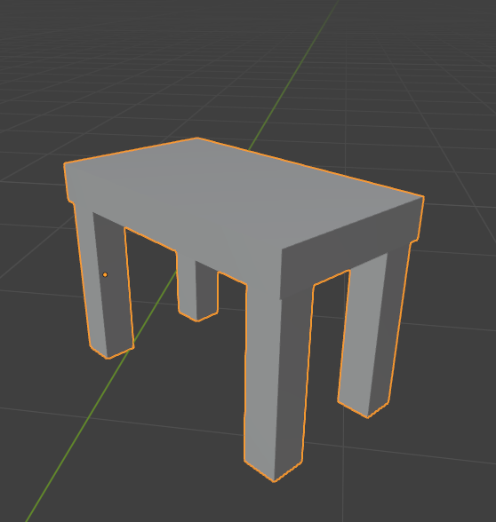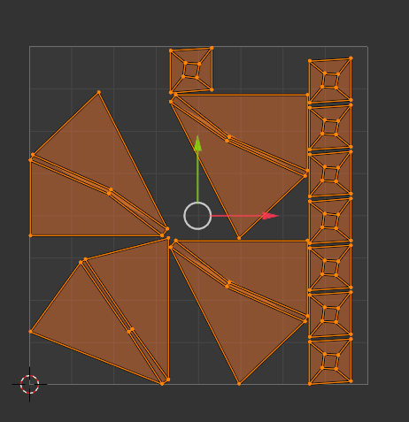

Stand 6
For stand 6 I went with more of a fish market type of stand. Then I started to work on the stand it was something easy and I used the same design that I had used before for the first stand making sure that the UV was the same and still optimized for the best possible UV.
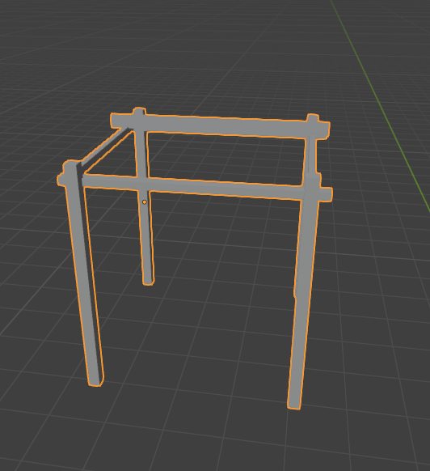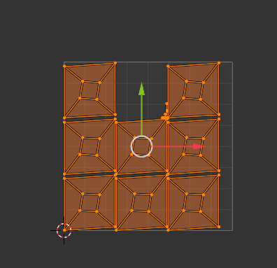
Next, I made a stand to place the boxes on them. this asset was the same as the one in the first stand I then checked the UV and made sure it was good.
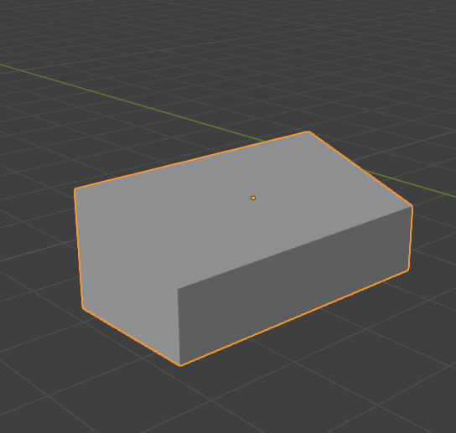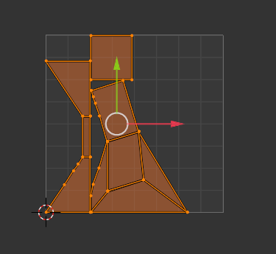

I then wanted to add textures inside of the boxes to add the illusion that fish are actually inside of the box. This was easy as all I had to do was make a plane inside of the box that fit around the edges.
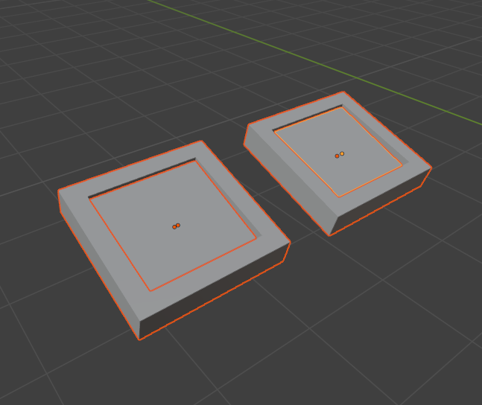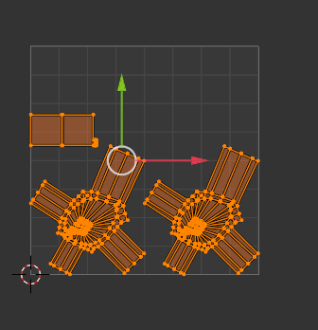

Then I made a box asset to hold the fish in, this was very easy as all I did was stretch the old model I had and changed the texture to make it match the theme more.
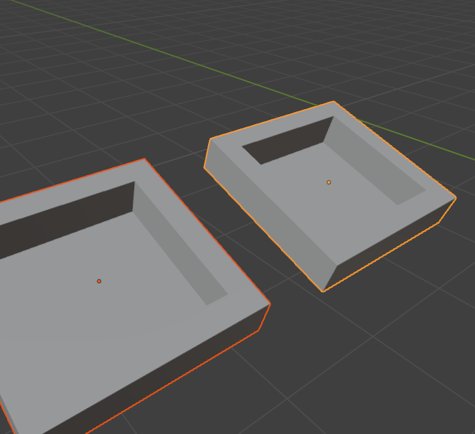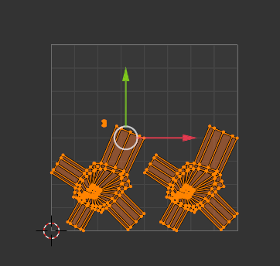

Path
For the path I wanted to make It come out of the ground to make it look more realistic and add depth to it, so what I did was I made a cube and extruded the sides out for the length that I wanted, then I randomised the vertices and then turned my camera on the Y axis and deleted most of the top layer for a pathway. I then used the scale tool to press everything down into one solid path which I then put inside of the floor.
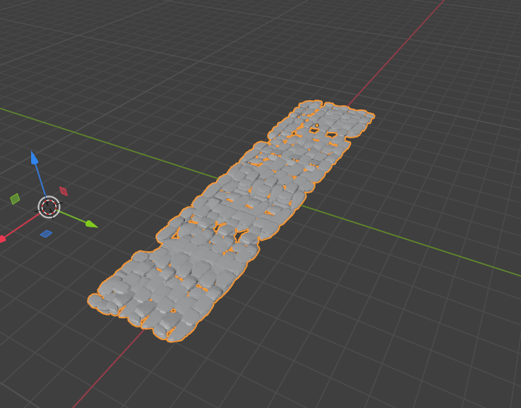

Cloth / collision for tarpaulin
For the tarpaulin on top of the stands I had to used multiple modifications to make it work at the start I tried to make a plane that was subdivided and I wanted to make it as realistic as possible so what I tried to do was move the vertices to match the stands aesthetic I then gave up for a couple of days and came back to it in that time I was learning how to make what I wanted and what I figured out is that I needed to add a cloth modifier to the plane. This would make it so when I started the slides it would make the plane fall as if its floating in the air. However, this also became a problem as it could cause lag and when I first tried it the plane would fall through all the structures. I then figured out how to make it touch into objects and collide with them, this would be by merging a mesh into one and adding the collision modifier. This made it so when the cloth was falling it would fall onto the stand and collide with it. Then after centring the cloth on the stand, I would play the animation. In the beginning I thought that it would be very hard to not make the project lag but I figured out that all I had to do to make the cloth less laggy and turn stationary when I wanted to keep it on the stand was turn the moving cloth into a mesh, this would make it so when it was in the desired position I would pause the video and convert it into a mesh with the convert to button with right click then I needed to make the mesh look better as I could still see the individual vertices. So, what I did was I smoothed the mesh, and it made it smoother so you could not see the vertices. When I checked the UV for this, I didn’t think it would need any changes for seaming it also the fact that the UV already took up the entire map.
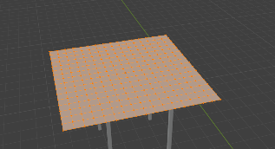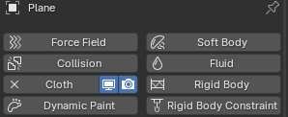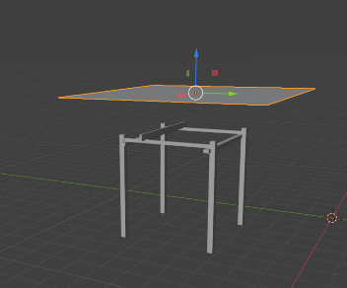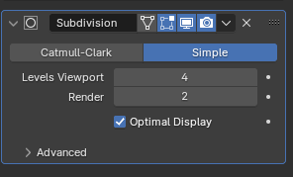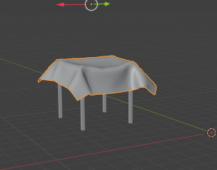

Texturing

Stand 1
For the first stand I wanted to try and make it as easy as possible so before I had already seamed it enough to make it suitable for me to texture. So all I had to do in substance painter was find a suitable texture for the stand to fit to I settled with a simpler wood texture, for the box texture I wanted to find a different wooden texture to match the medieval theme, this would be older feeling and duller I would also use this texture a lot for everything else however for the boxes I used a slightly different texture and rotated it so the texture and grain of the wood would match up to real life, this would make my textures more realistic then for the fruit on the inside I would have to search up a texture for the food, and to import it I would need to make sure that it is a JPEG file so I can directly import my texture into substance painter which I easily did by dragging and dropping into the files of substance. I then exported these textures into my textures folder and I went into blender, went onto the shading menu and used “control + T” to open the node wrangler setting which I selected the appropriate files and pressed import so I could get them into blender after that they instantly snapped onto the UV and mapped perfectly.
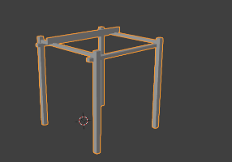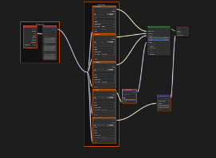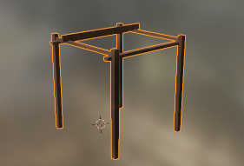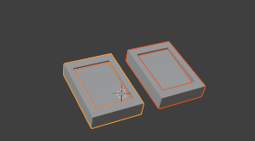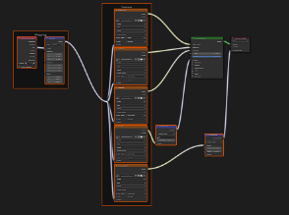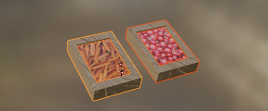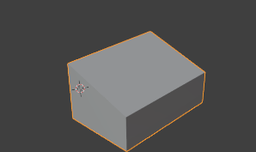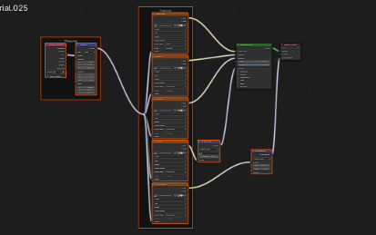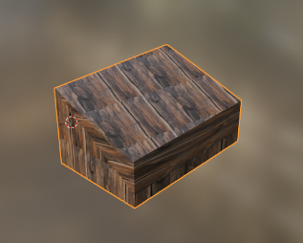

Stand 2
For the second stand I made sure to seam everything and made sure everything was seamed correctly then I took the stand into substance and used the same texture as I did before for the stands frame as it looked the best for what I was doing, for the beer mugs it was slightly harder to do and UV as they have a very specific mesh but when I figured it out it was easy and I made the mesh texturable so all I had to do was find a simple wooden texture that would fit for a beer mug. then it was time for the barrel. When making this model I over complicated it instead of using a cylinder and scaling it outwards I made a circle, extruded it, and filled it in both sides. Then I seamed the whole of it to make the UV acceptable for texturing. After this I needed to make the stands for holding the keg these were the easiest part, as all it was is extruded cubes. This meant that when I went to texture it I had to rotate the textures that I found and it was a pain to do, I think that if I did it again then I would make sure to make the UV more optimal, however, for the texturing all I had to do was fine a wooden barrel texture, which is very hard to match to all of the other wood on the stand, as most of the barrels are different colour wood, in the end I settled with a very simple barrel design and I pasted the texture into substance.
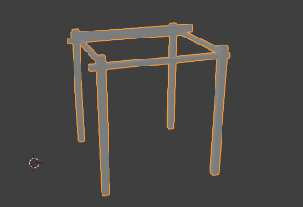
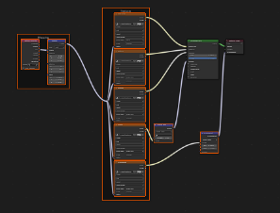
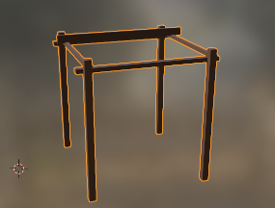
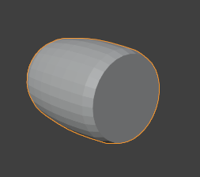
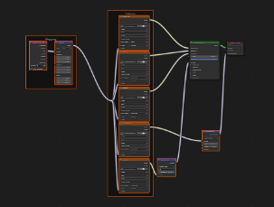
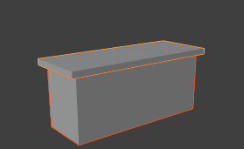
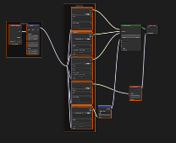
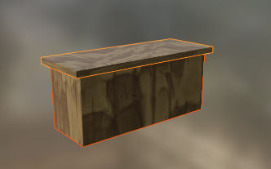
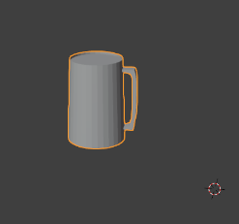
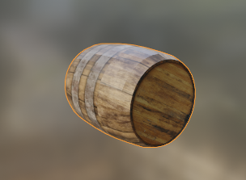

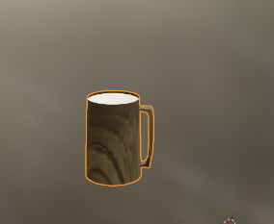
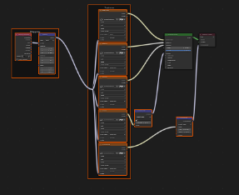

Stand 3
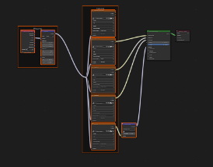
Texturing stand 3 was harder than the rest of the stands as it was a different structure to the rest of the other stands this made it very hard to texture as the structure was very hard to UV this caused me to have to seam a lot of things to make sure it was easier for me to texture all I needed to get for the frame was the same wooden image that I had used on previous stands. then I moved onto the inside of the stand for this stand it was pottery so I had to make a table which was easy all I did was I got a cube and extruded it until it fit the size of the stand, finding this texture was relatively easy again as it was provided with substance, I did not feel the need to find a different table texture as it was about as accurate to the medieval tables as I can. Then I started on the tabletop which was a cube that I scaled down to just over the size of the table which I then made the UV good by seaming the edges and unwrapping it. After unwrapping I used the same texture as the table base to make the top, this is so it would match to each other, and it would make more sense considering the time. Next, I started on the actual pottery I started off with a circle and I filled it in then I extruded the sides upwards, and loop cut the edges to make it come out the side. I tried to make this as realistic as possible to what pottery would be at the time. I then used a basic clay texture that I found on the internet, I made sure that it was old enough that it looked good for the time but not good for now standards. However, placing the texture on all of them was very easy due to the fact that I put all of the pottery on one UV.
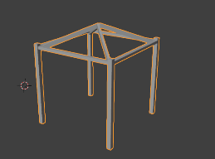
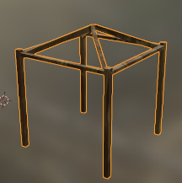

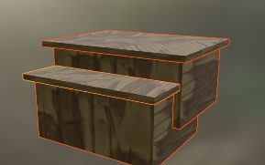
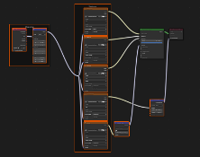
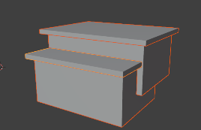

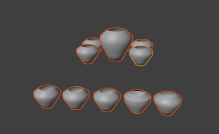
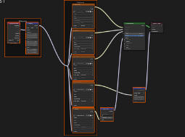
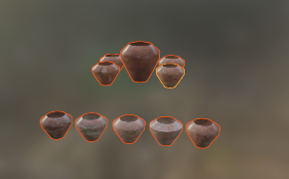
w

Stand 4
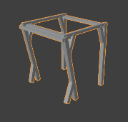
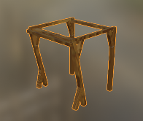
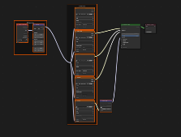
For stand 4 because of the different design of the stand and how it was shaped I needed to seam very carefully to make it as accurate as possible, after I had seamed the frame I went into my substance files and “control + T” to node wrangle all the old textures for the stands. After this I went onto the interior and for stand 4 it was a fruit stand so all I had to do was grab the old box texture and place it onto the new stand, I did the same for the boxes and for the inside textures (the fruits) I went onto google and found some JPEG images of fruit that I could use for inside the boxes.

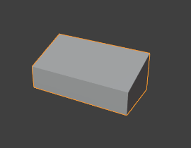
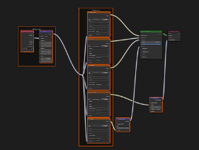
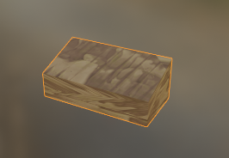

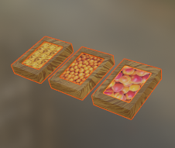
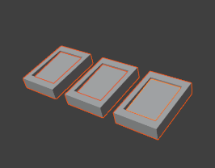
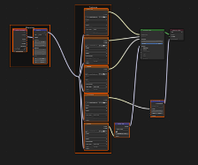

Stand 5
For stand 5 the stand was the same as it is for stand 3 so the texturing was just as simple as “control + T” and selecting all the PNG’s which (by using node wrangler) it auto wrapped the texture, then it was onto the interior, This was very tedious to do as most of the textures in this stand are very abnormal which means the UV is bad and when the UV is bad it means that texturing is also a pain to do, for the anvil I had to search up a metallic texture for a more rusted texture so it would fit the theme of an anvil. Then I started on the Log texture, this was so I could put the anvil on top of it this was very easy to texture as all I needed was the grain of the wood, the wood type (so I can get the correct grain) and a wood texture for bark. After this I started on the chair model, this model is very easy as it’s just made of long squares, so the UV wasn’t very bad for it, and it was very easy to texture. I just used the old wood texture I used and made it different slightly so it would stand out more. For the water barrel I wanted to add water on the inside so what I did was found a barrel texture and the inside of a barrel texture and then found a water texture, after I had got all of these textures I imported them into substance and drag and dropped them onto the texture and by using black mask I made them all fit. Then I used “control + T” to add all the textures to blender.
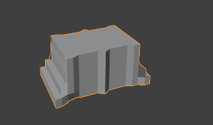
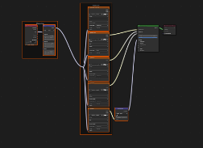
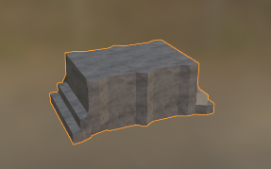
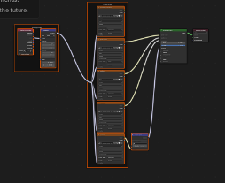
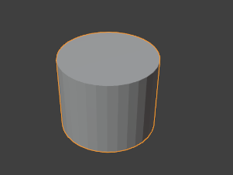

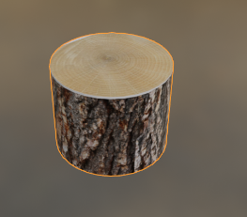

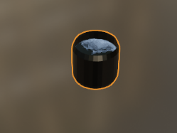
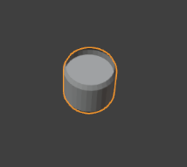
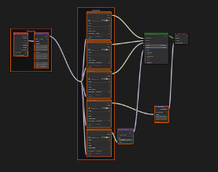

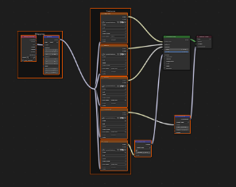
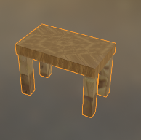
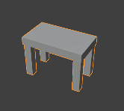

Stand 6
For the final stand it was again a relatively easy stand to do as all I had to do was get the old wood texture for the stands and import them onto the mesh which was very easy, then I started work on the inside of the stand, this was a fish stand so I went and gathered my textures. All I needed was a box texture a box stand texture and a frozen fish texture. After gathering all of these I went into substance and made the texture map for them. When I had made the texture map for them, I went back into blender and used “control + T” on the shaders menu to use the add-on node wrangler to import the textures easily onto the meshes.
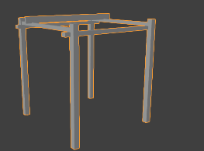
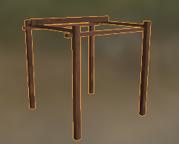
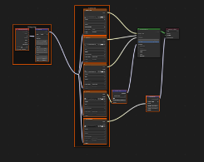

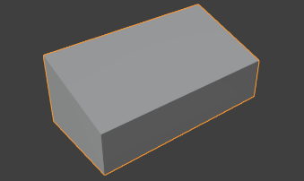
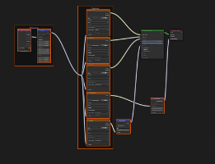
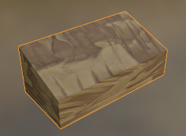

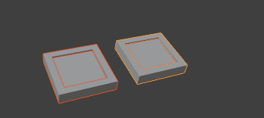
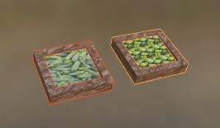
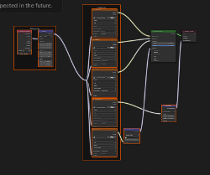

Cloth
For the cloth texturing these was as easy as it could be. All I had to do was go onto google and search up some textures that I thought would fit the medieval theme then import them as JPEG into substance. I did not think that any of the cloths needed to be textured as the UV was just a flat square image, however I did unwrap them so its easier to make sure they are accurate. Then I opened the shading menu for all of the cloth textures pressed the “+ new” button on the bottom of the menu. Then I selected the bigger box that was created. When it had a white outline to it, I knew that it was ready for me to use the “control + T” command. After using this it opened my folder, and I used the exported textures for each of them and textured every individual one.
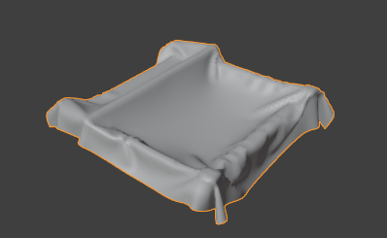
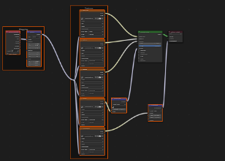
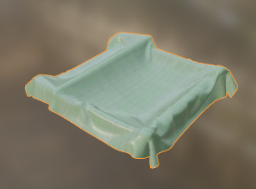

Path
For this I was very lazy with the way I could have done it, for the path I used a randomiser for the vertices and made them appear in random locations (with no overlapping) and then I checked the UV and it was one straight line so instead of fixing this issue I decided to keep it as one line and texture it like that, I know I should have changed it but due to time constraints and how late I did the path I decided to do that. This is entirely my fault, and I should have done it before and had better time management of this. But when I came to texturing it, all I did was find a colour I liked and pasted it into substance. Then I went back into blender and added it as a new texture with “control + T”
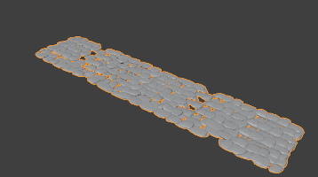
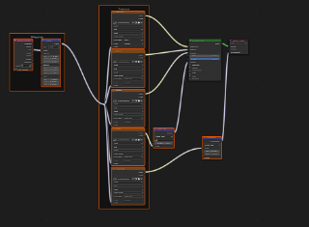
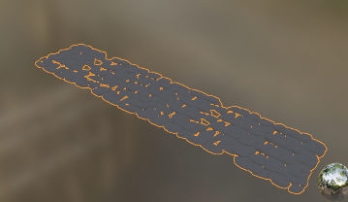

Unreal engine
For unreal engine I started off with a first person map and I started to delete everything that I didn’t need like the spawn and everything you start with so I had a clean slate, after I made my clean slate I added the camera item and the camera rig item, I then attached both of these together and after setting the camera to 0 – 0 – 0 coordinates I aimed it down to the centre and changed the yaw of the rig to make it look like it was looking down on the scene. After this I went into the settings for the camera and set a transform modification to where it would move 360 degrees in a small time frame this would make the camera spin around in a circle around a point (the camera rig) after this I went into blender and exported my files as .FBX files and then I drag and dropped them into the content drawer of unreal where I then selected them all and dragged them into the project. After everything had loaded my textures were already mapped onto the meshes and all I had to do was press record with the camera and it would render out a scene and put it in the file location.


